** The information contained in this document is for Educational Purposes ONLY **
Name: Mr. John Doe
Goal Amount: Rs. 1,00,00,000 Goal Term: 15 yrs
Investment Rate of Return: 12.00% Capital Gains Tax Rate: 12.50%

SIP Investment |  |  | Step-Up SIP Investment
 |  |  | SIP Step Up Rate: | 10.00%
Monthly SIP Amount: | Rs. 22,782 |  | Starting Monthly Amount: | Rs. 12,958
 |  |  | Ending Monthly Amount: | Rs. 49,210
SIP Maturity Amount: | Rs. 1,08,42,744 |  | SIP Maturity Amount: | Rs. 1,07,22,762
Total Money Invested: | Rs. 41,00,788 |  | Total Money Invested: | Rs. 49,40,670
Investment Gain: | Rs. 67,41,956 |  | Investment Gain: | Rs. 57,82,092
Capital Gain Tax: | Rs. 8,42,744 |  | Capital Gain Tax: | Rs. 7,22,762

Investment Performance - Value by Year

SIP Based Investment
Year | Investment Value | Year | Investment Value | Year | Investment Value
1 | Rs. 2,90,848 | 6 | Rs. 23,60,290 | 11 | Rs. 60,07,352
2 | Rs. 6,16,599 | 7 | Rs. 29,34,373 | 12 | Rs. 70,19,083
3 | Rs. 9,81,439 | 8 | Rs. 35,77,346 | 13 | Rs. 81,52,221
4 | Rs. 13,90,060 | 9 | Rs. 42,97,476 | 14 | Rs. 94,21,336
5 | Rs. 18,47,715 | 10 | Rs. 51,04,021 | 15 | Rs. 1,00,00,000

Step-Up SIP Based Investment
Year | Investment Value | Year | Investment Value | Year | Investment Value
1 | Rs. 1,65,434 | 6 | Rs. 15,98,600 | 11 | Rs. 47,20,030
2 | Rs. 3,63,955 | 7 | Rs. 20,51,537 | 12 | Rs. 56,64,036
3 | Rs. 6,00,526 | 8 | Rs. 25,79,075 | 13 | Rs. 67,49,643
4 | Rs. 8,80,772 | 9 | Rs. 31,91,606 | 14 | Rs. 79,95,731
5 | Rs. 12,11,061 | 10 | Rs. 39,00,851 | 15 | Rs. 87,00,779

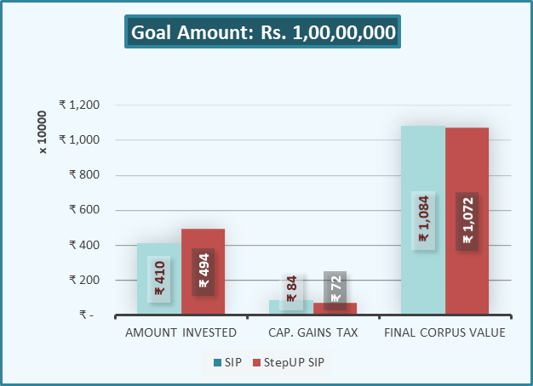

Cost of Delay

Delay | SIP Amount Required | Total Addt. Amount
3 Months | Rs. 23,566 | Rs. 70,479
6 Months | Rs. 24,383 | Rs. 1,41,866
9 Months | Rs. 25,234 | Rs. 2,14,165
12 Months | Rs. 26,120 | Rs. 2,87,381

Thank you for reviewing the customized Goal SIP Planner. We appreciate your trust in Nivra Fintech and remain committed to providing high-quality, goal-oriented financial solutions. Please contact us should you require any further assistance.

Nivra Fintech Team!
The Financial Engineers

